 2023 Kawartha Lakes AA 
Tournament Rules

OMHA Sanction #11697
- Hockey Canada and OMHA suspension rules shall apply where required. One Team Official MUST Register at Headquarters anytime on Friday. All teams will Carry a copy of their Official Approved Roster and Travel Permit.
- All U10-11-12-13 games will consist of 3 periods (10 minute-10 minute-10 minutes), stop time with the exception of U14, U15, which will consist of 3 periods of (10 minute –10-minute -15 minute) and U16 & U18, which will consist of 3 periods of (10 minute – 15 min – 15 minute) stop time. Floods for U16 & U18 will take place every 2 periods for back to back games or following each singular game or as required and may be deferred at the Arena Convenor discretion.
- There will be a 3-minute warm-up prior to each game All games will begin immediately upon completion of the 3-minute warmup. The game officials will supply a 1-minute warning to allow teams to prepare for opening face-off.
- All teams MUST be available to play up to 20 minutes prior to the scheduled start time at the discretion of the arena convenor.
- The OMHA minimum suspension guidelines will be strictly enforced. All suspensions will be enforced according to OMHA Constitution, By-laws, and Regulations & Rules.
- Hand Shake will take place before the start of each game.
- If the goal spread at any time of the THIRD period reaches 5 goals, the clock will run until the spread is reduced to 3 goals, then stop time will resume.
- One - 30 second timeout will be allowed for each team ONLY during: Elimination - Quarter – Semi-final & Championship games only. Overtime is not a new game. There is NO TIMEOUT in Round Robin Games.
- A maximum Hockey Canada Rule of 17 skaters and 2 goaltenders may be registered with each team.
- A player may only participate with one designated team in a tournament and may only participate in one tournament on any date.
- To be eligible to participate in the tournament, the participant’s name must appear on the team official roster form. Changes to the roster must be made in writing and will not be permitted after registration prior to the team’s first game. Players on Ontario teams must be registered with the OMHA as a “AA” Rostered Player or previous approved to play up.
- Teams will be awarded 2 points for a win, 1 point for a tie and zero (0) points for a loss.
- Standings after the round robin will be calculated on the basis of the points awarded as per rule # 12.
In the event of a tie, the following criteria will be used to break the tie:
- Winner between the tied teams when they played head-to-head. (Applies to 2-way ties only, 3 or more teams tied start with tie breaker 13b.)
- Percentage as calculated by dividing team’s total “Goals For” by the SUM of the team’s “Goals for and Goals Against”. TGF / (GF+GA) = % (See Tie Breaker Ratio Chart)
- Fewest Goals Against.
- Most Goals For.
- Fewest Penalty Minutes.
- Coin Toss.
- Follow Tie breaking rules in Order. Once a Tie Breaking Rule has been used or is not applicable it cannot be used again.
- IF a team(s) remove prior to the event (up to 72 hrs. before) every opportunity will be made to find a replacement team. If, however a team cannot be found where One or BOTH teams are unable to ice a team, or facilities breakdown / malfunction or game cancellation due to inclement weather, COVID and PHU or Provincials orders prevent teams from attending we will unfortunately NOT be able to reschedule the game. If unable to reschedule the game(s) will be considered as an Official OWHA Forfeiture score. It will be recorded as either 5-0 for a “single team no show” or if both teams are unable the score will be recorded as a Hockey Canada Forfeiture of a 0-0 tie for both teams to assist in determining rankings to find a divisional winner as required in conjunction with tie breaking rules. Tournament organizers and committees are not liable or responsible for acts of God and unforeseen events mechanical breakdowns, causing the cancellation of any part of whole if this event. ONLY 1 team official will sign the game sheet prior to each game.
- In U12 and U13 AA: 6 Team Pool – After 3 Round robin games 1st and 2nd overall will advance to the semi-finals. Teams 3-4-5-6 will play an elimination game with winners advancing to the semi-finals. Winner of the Semi finals will advance to the Championship final.
- In U10-11-14AA: 8 teams 2 pools of 4 teams. After 3 game RR all teams will advance to Quarter finals winners of Quarters advance to Semi and winners of Semi advance to Championship Finals
- In U18 AA: 10 teams = 2 pools of 5 teams: After 4 games round robin the top team in each pool will advance to the Championship Final.
- In U15-16 AA: 12 teams 2 pool of 6 teams: After round robin play 1st through 4th place teams in each pool will advance to the Quarter Finals. 5th and 6th place teams in each pool will play a consolation game. Winner of the semi-finals will advance to the Championship final.
- Elimination – Quarter - Semi-Finals & Championship games are played to a winner. In the event of a tie at the end of regulation time a Sudden Victory 5-minute overtime will commence. Teams will play 4 on 4 PLUS Goalies. (See format for rules) Players may be changed at any time. Goalies may be “pulled” at any time and a substitute player from the bench may be used. If still tied, a shoot out will occur.
- Shoot Outs: Teams do not change ends for Overtime or Shoot Outs.
Each team must designate 3 shooters (S1, S2, S3) directly onto the game sheet prior to the start of the game.
Any player serving a penalty at the end of overtime will not be eligible to participate in the shoot out and MUST remain in the penalty box. All players except shooter and goalies will be on the bench. Once a player has shot, they will go to the penalty box. Shooters from both teams will shoot simultaneously, starting at centre ice.
This is a BEST OF 3 Shootout. If still tied, each team will designate one shooter at a time until there is a winner.
A player may not shoot for a second time until all players on the game sheet (except goalies) have shot.
- Home teams must wear light colored jerseys where possible. In the event of a conflict, the home team must change their jerseys. Visiting teams will advise opposing team of any conflict 30 minutes prior to game time. Pinnies may be used as required.
- Each Team must have a Certified Coach and Trainer on the Bench at all Times. Only team officials on your official roster are allowed on the bench.
- Any Team Official walking across the ice surface before or after their Game will result in a 2-minute Bench Minor. Only exception to this is if there is an injury to one of the Players on the ice. Penalty will be served at the start of the game or if infraction happened after the game penalty will be served at the start of the Team's next game.
- Any Player or Team Official receiving a Gross Misconduct (GRM) or Match Penalty (MP) will be automatically suspended from any further Play in the Tournament. There will be no exceptions to this rule. Any Player or Team Official receiving a penalty listed on the Game Sheet as a GRM (Gross Misconduct) Penalty will be automatically SUSPENDED from the Tournament. All Suspensions are reported to OMHA and forwarded on to the GTHL, Alliance, ODMHA, or other Non OMHA League at the close of the Tournament
- Any Spectator, Player, or Team Official being verbally aggressive or physically aggressive with Referees, Other Players, Team Officials, Tournament Officials, or other Spectators will be asked to leave the Playing Area and possibly the Arena depending on the situation. Police will be called if necessary.
- Only Players, Coaches, Trainers, Managers, or Tournament Volunteers are allowed in Dressing Rooms or Dressing Room Hallways before and after games. PARENTS / SIBLINGS are not to be in Dressing Room Hallways. Please ask Parents to wait in Lobby Areas to help keep congestion down in the Hallways for Players and Teams coming and going.
- It is the team’s responsibility to ensure a clean dressing room is left upon completion of their game. All teams are requested to vacate the dressing room 30 minutes or less after their game is completed.
- PLEASE NOTE: Any damage to or a Dressing Room or any part of the facilities who leave a mess or cause damage will result in the Team receiving an invoice from the City of Peterborough for the damage and or clean up. The Team's Association will also receive a copy of the bill along with a letter informing them.
- The decisions of the Tournament Officials and Referees are final with no appeals!
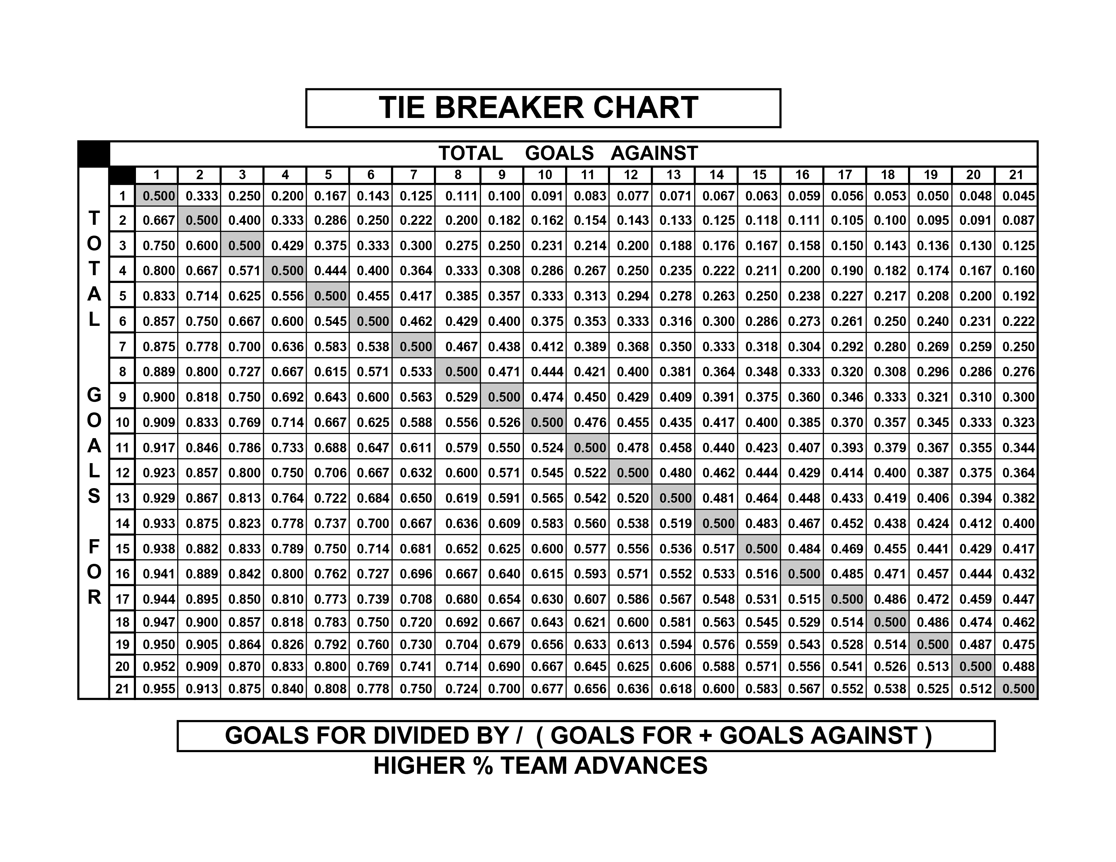
2023 Kawartha Lakes AA
OVERTIME RULES FOR
Elimination, Quarter-final,
Semi-final and Championship Games
OMHA Sanction #11697

- Elimination, Quarter-final, Semi-final and Championship games are played to a winner.
- In the event of a tie at the end of regulation time a SUDDEN VICTORY FIVE (5) MINUTE OVERTIME will commence.
- Overtime will be played 4-on-4, plus goalies
  - Any penalties being served at the end of regulation time will carry over to the overtime period.
  - Example 1: If a team is one player short, then overtime will start 4-on-3.
  - Example 2: If a team is 2 players short, they OT will start 5-on-3. On ice strength will be adjusted back to 4-on-4, as per OT rules, at stoppages of play after the penalties expire.
- Clarifications:
  - If a penalty is assessed to one team during the overtime period, play shall resume 4-on-3
  - Should a second penalty be assessed to the same team, play will resume 5-on-3 until the expiry of the first penalty.
  - If the penalty expires during play, the player shall return to the ice and teams will play 5-on-4 until the next stoppage of play, at which point the on-ice strength will be adjusted to 4-on-3, etc.
  - At no time will a team have fewer than 3 skaters (plus goalie) on the ice
- Teams will play 4 on 4 plus goalies. Players may be changed at any time. Goalies may be “pulled” at any time and a substitute player from the bench may be used.
- Penalties do NOT expire at the end of regulation time.
- If still tied, a shoot out will occur.
- Each team MUST designate 3 shooters (S1, S2, S3) on the game sheet BEFORE the start of the game.
- Any player(s) serving a penalty at the end of overtime will not be eligible to participate in the shoot out and MUST remain in the penalty box. The coach must RE-designate a shooter(s) to take her SPOT / Place(s) immediately at the end of regulation time.
- All players except shooter and goalies will be on the bench TO START.
- Shooters from both teams will shoot at the same time starting at the centre ice red line.
- Once a player has shot, they will go directly to the penalty box.
- This is a BEST OF 3 Shootout.
- If still tied, each team will designate one shooter at a time until there is a winner.
- A player MAY NOT SHOOT for a second time until all players on the game sheet signed (except goalies) have shot.
- A penalty assessed in regular time will carry forward to the overtime period. Therefore, the player will not come out of the box.

*WE RESPECTFULLY ASK FOR YOUR ASSISTANCE IN THAT NO TEAM PHOTOS
BE TAKEN ON ICE DUE TO Municipality & City Insurance Regulations.
*Championship Awards and Medals MAY be Presented Off-ice if deemed by Tournament Officials due to time Constraints and will be presented at a determined location as required.
We thank you for your anticipated support in this matter.

